**Observation**

Inspection was undertaken at the subject property in the presence of the Insured to which the following observations was noted:

### Swimming Pool Structure

1. The pool construction consists of metal sheets carcass and supporting uprights which has been lined with a plastic waterproof membrane and Styrofoam panels utilised as stairs.
2. At time of inspection, the Styrofoam stairs were observed to have uplifted together with the polyurethane liners and separation of horizontal coping members at the butting joint. **Images 4 -6**

1. In our opinion, the construction of the pool is typical of a pre-fabricated “above ground” swimming pool system.
2. The embedment of the pool structure into the ground has resulted in “in-ground” application of the subject pool system contrary to the “above-ground” intended design and function.
3. In saying this, in contrast to “in-ground” pool systems, “above-ground” pool systems are not generally designed to withstand soil and hydrostatic pressures from the exterior of the pool and have been designed for containment of **pool water pressure only**.
4. In this case, the exerted earth and hydrostatic pressure onto the pool carcass associated with its construction in an “in-ground” system capacity is beyond the design function and intent of an “above ground” pool structure and its carcass.
5. In illustrating the mechanism of failure, we have provided a schematic diagram of the earth pressure and hydrostatic pressures acting on the external face of the pool structure in ***Figure 2.***

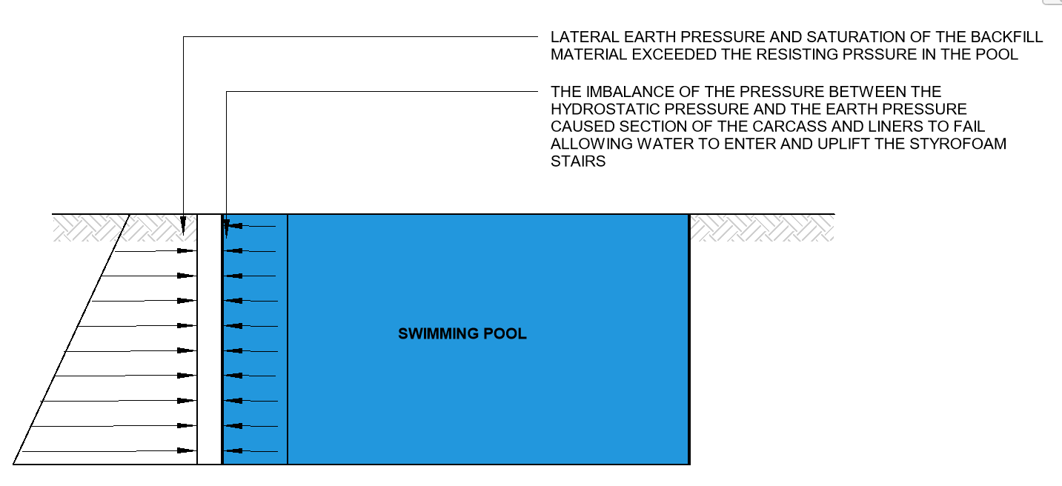

**Figure 2 - Schematic Diagram of Resultant Internal & External Pressures Acting on the Pool Structure and Carcass Resulting in the Buckling and Damage as Observed.**

1. On the above basis, the imbalance of the pressure between the earth pressure and the hydrostatic pressure from the water in the pool has ultimately exceeded equilibrium within the pool structure’s stability causing failure and buckling about section of the carcass and liners as experienced.
2. The loss of equilibrium between the resisting internal pressure and the applied external pressure has caused imbalance and ultimately the loss of the pool structure’s integrity.
3. As such, saturation of the backfill material during the experienced storm together with hydrostatic build-up against the pool carcass has exceeded the design capacity of the pool structure resulting in the observed failure and buckling of the pool liner and uplift of the Styrofoam stairs.
4. In our opinion the movement of the carcass has allowed for the disengagement of the polyurethane membrane allowing water to enter below the Styrofoam staircase and cause the experienced uplift.
5. In our opinion, the subject “above ground” pool system was not designed to be used for “in-ground” application.
6. In addition, the use of the Styrofoam stairs is grossly inadequate and unsuitable as the density of Styrofoam is very low compared to water, making it buoyant during saturation of foundation material.
7. In saying this, if the pool was correctly constructed as an in-ground pool using concrete wall or fibreglass in accordance with the manufacturer’s specification, the observed damage would not have occurred irrespective of the severity of the storm.
8. On the above basis, the observed damage is **unrelated to an insurable event and the failure can be solely contributed to the inadequacy of the pool construction constructed 11 months ago adopting above ground pool system for in ground application.**

**Discussion**

NA

**Conclusion**

In our opinion, the cause of damage to the pool is attributable to the following circumstances and factors:

1. The current pool configuration is an “above ground” system which has been installed as an “in ground” swimming pool.
2. An “above-ground” pool system is designed for the containment of **internal pool water pressure only**, whilst “in-ground” pool systems are designed to withstand both internal water pressure and soil and hydrostatic pressures from the exterior of the pool.
3. High saturation of surrounding fill by high rainfall activity during the storm event and hydrostatic pressure build up.

In combination with the above-mentioned factors, the imbalance of the pressure between the earth pressure and the hydrostatic pressure from the water in the pool has ultimately exceeded equilibrium within the pool structure’s stability causing failure and buckling about section of the carcass and liners as experienced.

The loss of equilibrium between the resisting internal pressure and the applied external pressure has caused imbalance and ultimately the loss of the pool structure’s integrity.

As such, saturation of the backfill material during the experienced storm together with hydrostatic build-up against the pool carcass has exceeded the design capacity of the pool structure resulting in the observed failure and buckling of the pool liner and uplift of the Styrofoam stairs.

In our opinion, the movement of the carcass has allowed for the disengagement of the polyurethane membrane allowing water to enter below the Styrofoam staircase and cause the experienced uplift.

In our opinion, the subject “above ground” pool system was not designed to be used for “in-ground” application.

In addition, the use of the Styrofoam stairs is grossly inadequate and unsuitable as the density of Styrofoam is very low compared to water, making buoyant.

In saying this, if the pool was correctly constructed as an in-ground pool using concrete wall or fibreglass in accordance with the manufacturer’s specification, the observed damage would not have occurred irrespective of the severity of the storm.

On the above basis, the observed damage is **unrelated to an insurable event and the failure can be solely contributed to the inadequacy of the pool construction constructed 11 months ago adopting above ground pool system for in ground application.**